

HAPPY
SUMMER!
A Bi-monthly Newsletter July - August 2026



www.pacifcafriendsofthelibrary.org
As always, we can use more volunteers like book nook workers, or even Board members. Contact Carl Schwab or Joan Putz at pfol94044@gmail.com if you can help out. For more information, go to www.pacificafriendsofthelibrary.org
Thank you for a good year; and we look forward to another one next year.
Carl Schwab and Joan Putz, Co-presidents
June Book Sale Report
Thank you to Cyndi Sevenants and Laurie Jacobsen who stepped forward to organize this June’s book sale...Joan Putz did a terrific job of recruiting. Thanks also to the many volunteers who helped set up, staff, and take down the sale. It was hard work, but thanks to the wonderful people who came to help, it was fun and a big success. We made $3,618.75 for library programs. Big thanks to the Fabulous Four who answered the call to tote the left-over books to the parking lot.
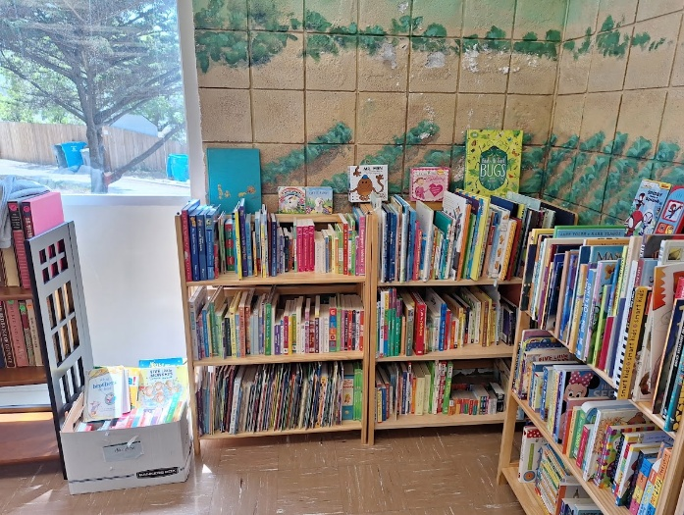
The calm before the storm! Thanks Putz family!
A Message From the Co-Presidents
July marks the beginning of the new fiscal year for us. This has been a good year for the PFOL. We have many generous donors, and, in addition, our two book sales raised about $7,000 this fiscal year. This has allowed us to support many Pacifica Library programs and services in the past and going forward into the future.
Pacifica has a new summer intern, Bella. She will be supporting a variety of youth programs. We welcome Bella to the Pacifica libraries team.
With your San Mateo County libraries card, you now get free access to “Creative Bug”, an online learning platform featuring more than 5,000 instructional videos on crafts like knitting, jewelry making, sewing, canning, bookbinding and more. “Creative Bug” offers expert-led classes with materials lists, note taking tools, and helpful resources. Browse projects by category, including quilting, paper crafts, crochet, and even a section just for kids. This is a great resource to combat the “I’m bored” complaints during summer. Get busy and have some fun crafting!
We just had our election of officers at our June 25th 2026 board meeting. The following people were elected for the July 1, 2026 through June 30, 2027 term:
Co-Presidents: Carl Schwab and Joan Putz Vice President: Kathy King Treasurer: Susan Omran Secretary: Laurie Jacobsen Web Mistress: Dru Daley

Events *registration required*
Wed. 7/8* Postcard Party* create your own postcard Sanchez 3:00-4:15
Sat.7/11 *Financial Literacy Workshop: Better- than- Nothing- Estate Plan * Sharp Park 2:00-3:15
Thurs. 7/16 *55+ Field Trip to Curiodyssey *at Coyote Point by bus. Sharp Park 9:00-3:00
Wed. 7/22 Juggling and Hambone with Unique Derrique comedy juggling show Sanchez 3:00 -3:45
Tues. 7/ 28 Electric Storyland musical show with Sippy Mark Sharp Park 3:00-4:00
Thurs. 7/30 Maker Extravaganza Drop in 11:OO-7:00 Use a sewing machine, 3D printer, laser cutter etc. Sharp Park Library
Tues. 8/11 Circus and Comedy with Coventry and Kaluza Sharp Park 3:00

As mentioned earlier, July marks the new fiscal year for us. At the June meeting the Board approved the budget for expenditures for 2026-7 for programs and services.
1.Programming and Outreach Support for All Ages: (Presenters, refreshments, program and outreach supplies) $5,000
2.Staff Development and Recognition: (Staff training opportunities and recognition activities) $1,000
3.Volunteer Recognition: (Volunteer Recognition Activities) $1,000
4. Imagination Library (a free book every month for every child in S.M. Co. ages 0-5) $8,000
5. Bookmobile (Providing library services throughout the County) $5,000 Our contribution to a new electric bookmobile. More information to follow in next newsletter.
Grand total $20,000 A special THANK YOU to all our generous donors who make all of this possible.
Happy Birthday America!
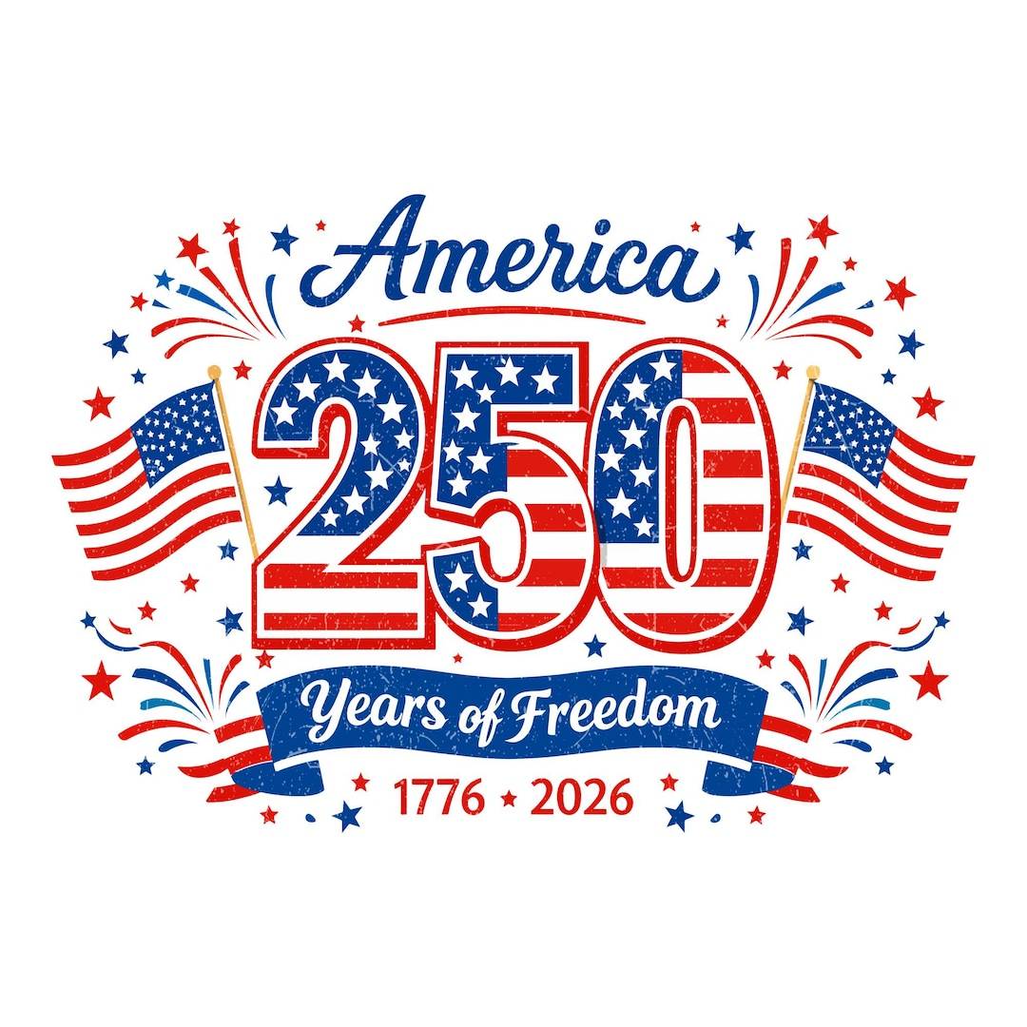

Summer Fun at Sanchez Library with bubblemeister Sterling Johnson at the Bubbles, Bubbles, Bubbles program.
Happy summer!
